1. The setup and loop functions are included in every Arduino program. The setup function runs one time and is often used to initialize the variables. The loop function runs as long as the board has power and executes the actual code for the program. This is where a majority of the work goes in building an Arduino project.
2. The pinMode function configures a pin to be set to either input or output.
3. 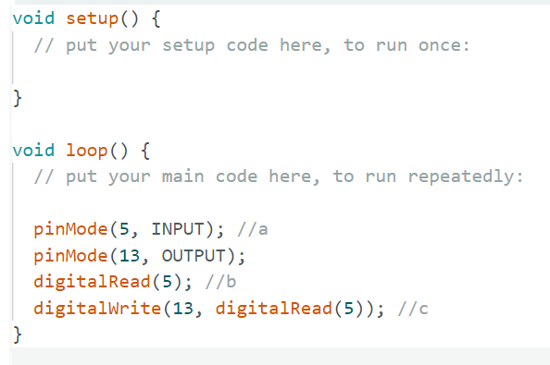
4. Graphical user interface, text, application

   Description automatically generated
5. V=IR

R = V/I

R = (5V – 2V)/20mA = 3V/20mA

R = 150Ω

1. Software based button debouncing solves the mechanical issue of multiple voltage changes from max to min in a short interval when the button is transitioning from open to closed, where it has a loose connection. It is achieved by having an appropriate delay following a button press, to make the system think that it was only pressed once. This avoids the issue of having one button press appear to the system as many presses.